Wilbur Wright College
CIS114 – Mobile Applications

Prof. Gustavo Alatta Student name: ____________Jorge Mendez______9/1/26____
Lab1

Objectives: The main objective of this lab is to measure your expertise using the main interface of Android Studio and basic image manipulation.
Deliverables:
- A MS Word document (use this Word document) with the following:
  - The screenshot of your final product.
  - Copy of your XML (contain_main.xml)
Procedure:
- Using any Image manipulation Software design an image 800x300 pixels using any color background that contains the picture of a celebrity and the word “Quotes”.
- Search for a famous quote of the celebrity you choose. Add that quote to your strings.xml
- Design your screen adding 1 Imageview and 2 Textview (1 for the quote and 1 for the name). All TextView values must use the strings.xml
- Change the colors for the whole layout updating the color.xml.
- Run your App.
Mockup Sample:

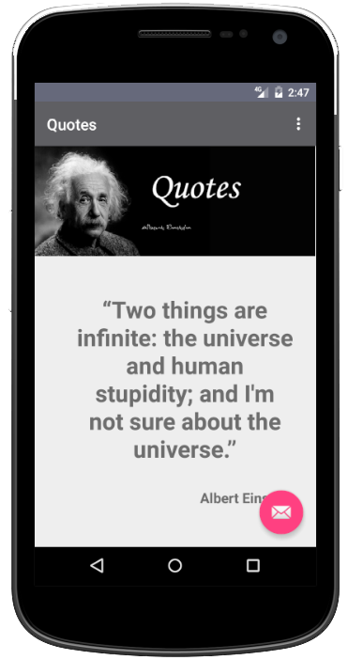

<?xml version="1.0" encoding="utf-8"?>
<androidx.constraintlayout.widget.ConstraintLayout xmlns:android="http://schemas.android.com/apk/res/android"
xmlns:app="http://schemas.android.com/apk/res-auto"
xmlns:tools="http://schemas.android.com/tools"
android:id="@+id/main"
android:layout_width="match_parent"
android:layout_height="match_parent"
tools:context=".MainActivity">
<TextView
android:layout_width="wrap_content"
android:layout_height="wrap_content"
android:paddingLeft="10dp"
android:paddingRight="10dp"
android:text="@string/quote"
android:textAlignment="center"
android:textColor="@color/purplegray"
android:textSize="50sp"
android:textStyle="bold"
app:layout_constraintBottom_toBottomOf="parent"
app:layout_constraintEnd_toEndOf="parent"
app:layout_constraintHorizontal_bias="0.0"
app:layout_constraintStart_toStartOf="parent"
app:layout_constraintTop_toTopOf="parent"
app:layout_constraintVertical_bias="0.602" />
<TextView
android:layout_width="wrap_content"
android:layout_height="wrap_content"
android:text="@string/nikola"
android:textColor="@color/purplegray"
app:layout_constraintBottom_toBottomOf="parent"
app:layout_constraintEnd_toEndOf="parent"
app:layout_constraintHorizontal_bias="0.865"
app:layout_constraintStart_toStartOf="parent"
app:layout_constraintTop_toTopOf="parent"
app:layout_constraintVertical_bias="0.866" />
<ImageView
android:id="@+id/myImageView"
android:layout_width="wrap_content"
android:layout_height="wrap_content"
android:src="@drawable/tesla_quote"
app:layout_constraintBottom_toBottomOf="parent"
app:layout_constraintEnd_toEndOf="parent"
app:layout_constraintHorizontal_bias="0.0"
app:layout_constraintStart_toStartOf="parent"
app:layout_constraintTop_toTopOf="parent"
app:layout_constraintVertical_bias="0.0" />
</androidx.constraintlayout.widget.ConstraintLayout>
